**Step 1: Create a deployment environment**

* To start, open the Elastic Beanstalk console and choose Create Application.
* For Application name, enter demoelb. Select PHP from the dropdown menu . choose Create application.

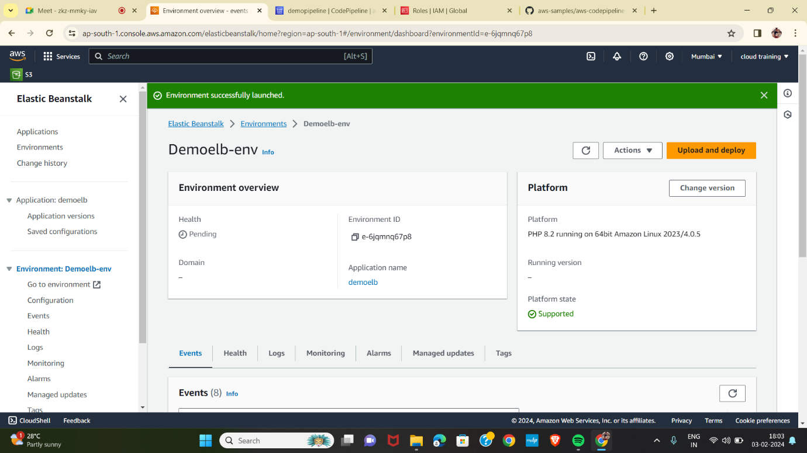

**Step 2: Get a copy of the sample code**

* If you would like to use your GitHub account:Visit our GitHub repository containing the sample code at https://github.com/aws-samples/aws-codepipeline-s3-codedeploy-linux.

**Step 3: Create your pipeline**

* Open the AWS CodePipeline console.choose Create pipeline.
* Pipeline name: Enter the name for your pipeline, DemoPipeline
* Add source stage page, select the location of the source you selected and follow the steps below:.Select GitHub (Version 2) for the Source provider.Choose Connect to GitHub.
* Enter demoelb for Connection name and choose Connect to GitHub.
* Select Authorize AWS Connector for GitHub.
* When redirected back to the connection screen, choose Install a new app.
* The Add source page will be updated to reflect GitHub is ready to connect. Specify the repository and branch:Repository name: select the GitHub repository you want to use as the source location for your pipeline. Select the forked repository in your GitHub account named aws-codepipeline-s3-codedeploy-linux.Branch name: select the branch you want to use, master.Output artifact format: Select CodePipeline default.
* Select Skip. Select AWS Elastic Beanstalk. Retain the default region. Select demoelb Env.Select Demoelb-env.

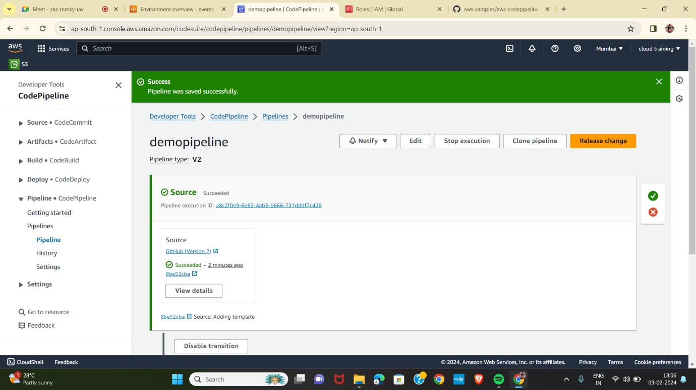

**Step 4: Activate your pipeline to deploy your code**

* Select AWS Elastic Beanstalk.
* 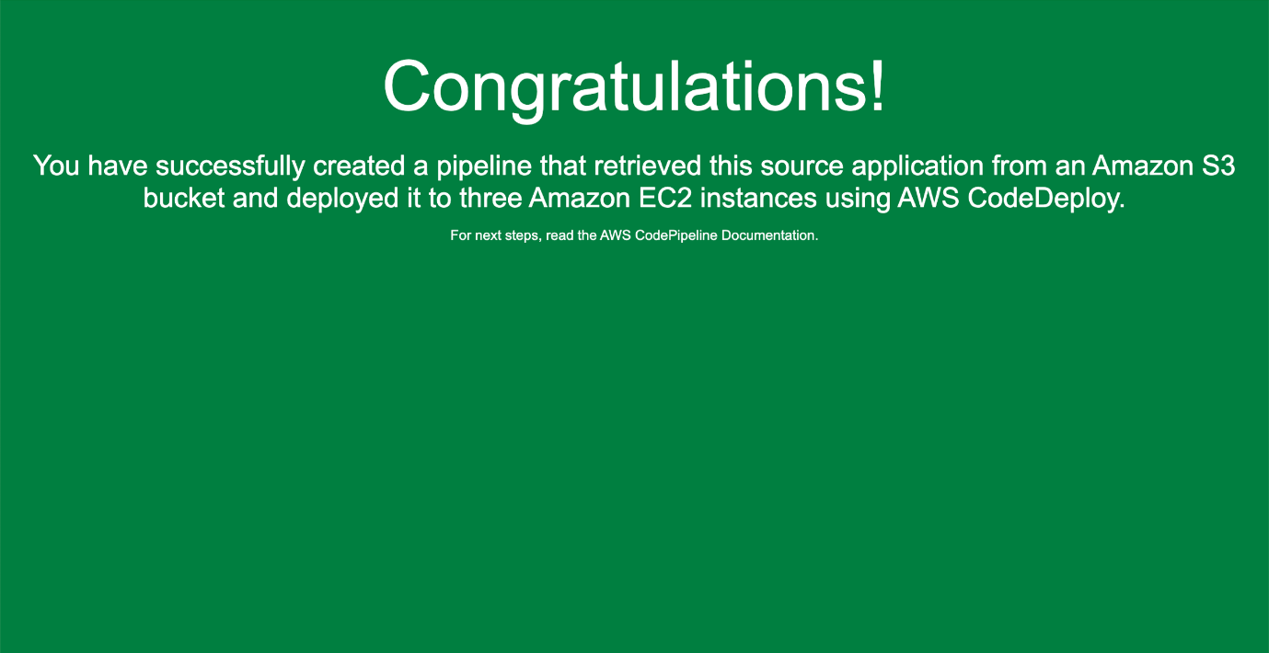Select the URL that appears in the upper-right part of the page to view the sample website you deployed.